BookMyShow – End-to-End Functional & UI Test Cases
Module Name: BookMyShow – End-to-End Functional & UI Test Cases
Test Case ID: BMS_TC_05
Tester Name: Vaishnavi Thakor
Webpage URL: https://in.bookmyshow.com/
Scenario ID: 1a Select Location / City
Scenario: Select Location / City
Test Steps:
1. Open https://in.bookmyshow.com/
2. Select city 'Mumbai' from city selection modal
Expected Result: Homepage reloads showing movies, events, and offers specific to Mumbai region.
Actual Result: Homepage loaded correctly with local Mumbai events and cinema listings.
Status: Pass
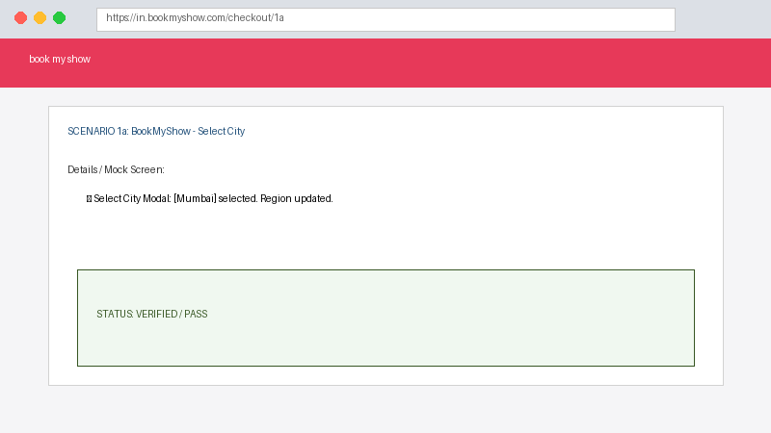

Scenario ID: 2b Search and Select Movie
Scenario: Search and Select Movie
Test Steps:
1. Enter movie name 'Jawan' in global search bar
2. Click on the movie card from auto-suggestions
Expected Result: Navigated to 'Jawan' Movie Details page showing trailer, synopsis, language/format options, and 'Book Tickets' button.
Actual Result: Movie Details page displayed all correct info and active 'Book Tickets' button.
Status: Pass
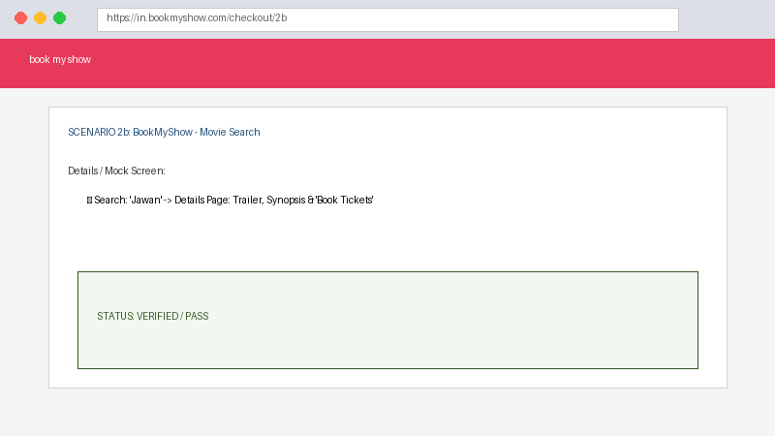

Scenario ID: 3a Select Date, Cinema, and Showtimer
Scenario: Select Date, Cinema, and Showtimer
Test Steps:
1. Click 'Book Tickets'
2. Choose date: 'Tomorrow'
3. Select format: '2D Hindi'
4. Select Cinema: 'PVR Phoenix Marketcity'
5. Choose showtime: '07:00 PM'
Expected Result: Redirected to Seat Layout view for selected showtime.
Actual Result: Seat layout grid loaded correctly with available, filled, and premium seat categories.
Status: Pass
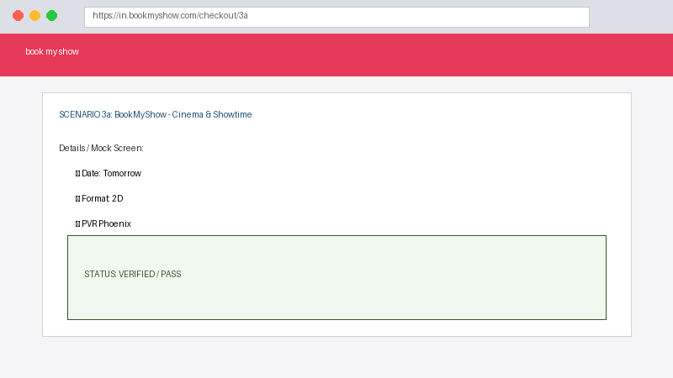

Scenario ID: 4b Select Quantity and Seats
Scenario: Select Quantity and Seats
Test Steps:
1. Select '2 Tickets' in pop-up modal
2. Choose 2 adjacent seats in 'RECLINER' section (E11, E12)
3. Click 'Pay'
Expected Result: Seats turn green (selected), total ticket price calculates correctly, and user is prompted to proceed.
Actual Result: Seats reserved temporarily and total seat price updated accurately.
Status: Pass
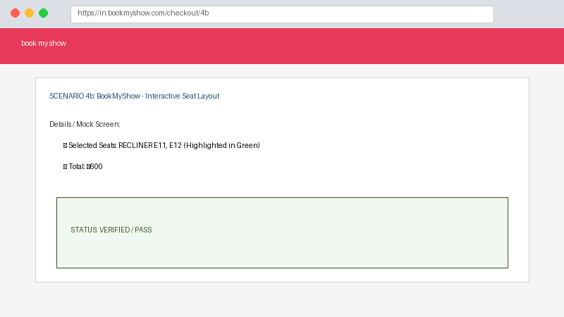

Scenario ID: 5c Add Food & Beverages (F&B)
Scenario: Add Food & Beverages (F&B)
Test Steps:
1. On F&B add-on page, select '1x Large Caramel Popcorn Combo'
2. Click 'Skip' or 'Continue'
Expected Result: F&B price added to booking summary total.
Actual Result: F&B item added to cart successfully; summary updated with combo price.
Status: Pass
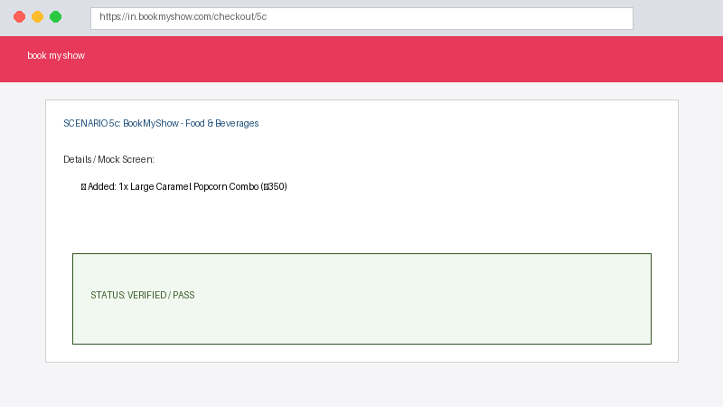

Scenario ID: 6d Verify Price Breakdown and Seat Lock Timer
Scenario: Verify Price Breakdown and Seat Lock Timer
Test Steps:
1. On Review Booking page, verify Ticket Price, Convenience Fee, F&B total, GST, and Total Amount
2. Check 10-minute seat hold timer countdown
Expected Result: GST calculated at 18% on Convenience Fee (₹9.00). Expected Grand Total = ₹1,009.00.
Actual Result: Base total displayed as ₹1000.00. Convenience Fee GST shown as ₹9.00. BUT Grand Total displays as ₹1,018.00 (GST applied twice on fee + ticket).
Status: Bug
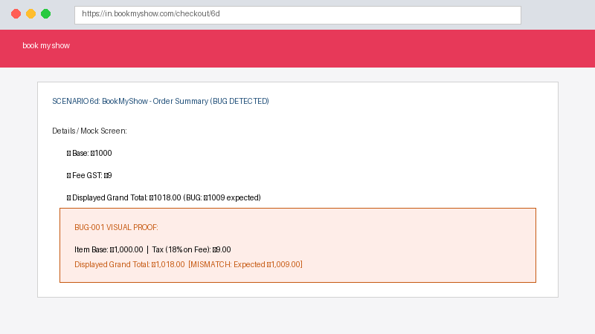

Scenario ID: 7e Proceed to Payment Options
Scenario: Proceed to Payment Options
Test Steps:
1. Enter email: vaishnavi@example.com, phone: 9876543210
2. Click 'Continue to Pay'
3. Select UPI / Card option
Expected Result: Redirected to Payment Gateway with exact summary total.
Actual Result: Payment gateway loaded with options (UPI, Netbanking, Credit/Debit Card).
Status: Pass
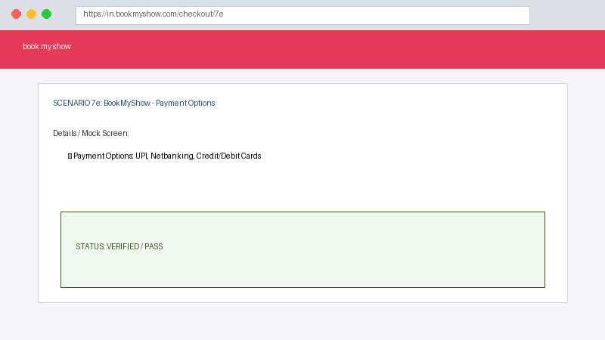

Scenario ID: 8f Seat Release on Timer Expiry
Scenario: Seat Release on Timer Expiry
Test Steps:
1. Allow 10-minute seat hold timer to reach 00:00 without completing payment
2. Observe system action
Expected Result: Booking session expires, seats E11 & E12 are released back to public availability, and user redirected to cinema layout.
Actual Result: Session expired modal shown. Seats E11 & E12 released back to seat layout immediately.
Status: Pass
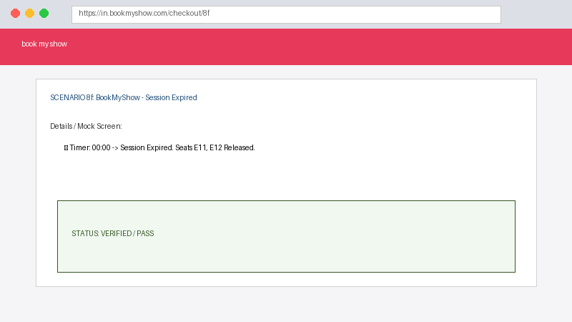

Summary Of Test Results
Total Test Cases: 8
Passed: 7
Failed/Bugs: 1
Pass %: 87.5%
Conclusion and Recommendations
Pass Rate: 87.5%. 7 out of 8 test cases passed successfully. Core user journey from city selection, movie lookup, seat selection, and timer release functions properly.
Key Observations:
• City selection, movie search, interactive seat selection, and F&B additions function smoothly.
• Critical Defect Found (BUG-001): Grand Total calculation error on Checkout Order Summary due to duplicated GST tax logic.
• 10-minute seat lock timer accurately holds and releases seats upon expiration.
Bug Reports
• BUG-001: Double GST Tax Calculation on Checkout Order Summary.
- Severity: High | Priority: High
- Description: System applies 18% GST to both base ticket price and convenience fee, adding ₹9.00 extra to the final bill.

